**BIOINFORMATICS ASSIGNMENT 1 (Day 1 - 5)**

***Note: You will be added in a slack community of Bversity for further doubts and communications***

1. Gene Name: tumour protein p53

2. Function of the Gene: Codes for a tumour suppressor protein

3. NCBI accession number: NC_000017

4. Forward Primer: TCCATACTACTACCCATCCA

5. Reverse primer: GTCCTACCTGTCCCATTTAA

6. Features of primers:

1. Primer length: 20 (both)
2. Primer temperature: 53.98 (Forward); 54.03 (Reverse)
3. GC%: 45%

7. Amplicon length and sequence:

CCTCTCATCACATCCCCGG

CGGGGAATCTCCTTACTGCTCCCACTCAGTTTTCTTTTCTCTGGCTTTGGGACCTCTTAA

CCTGTGGCTTCTCCTCCACCTACCTGGAGCTGGAGCTTAGGCTCCAGAAAGGACAAGGGT

GGTTGGGAGTAGATGGAGCCTGGTTTT (206 bp)

**qPCR Data analysis (DAY 5)**

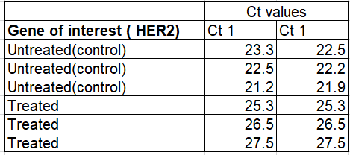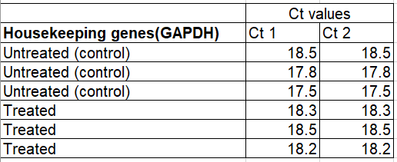

The following data are results of qPCR from cancer cell lines. HER2 stands for human epidermal growth factor. It’s healthy in normal amounts, but too much may be a sign of a certain type of breast cancer. Calculate the 2 Delta Ct values for the following data and plot the values on a graph using graphpad pris

